**Native American and Indigenous Muslim Stories Portrait Exhibit**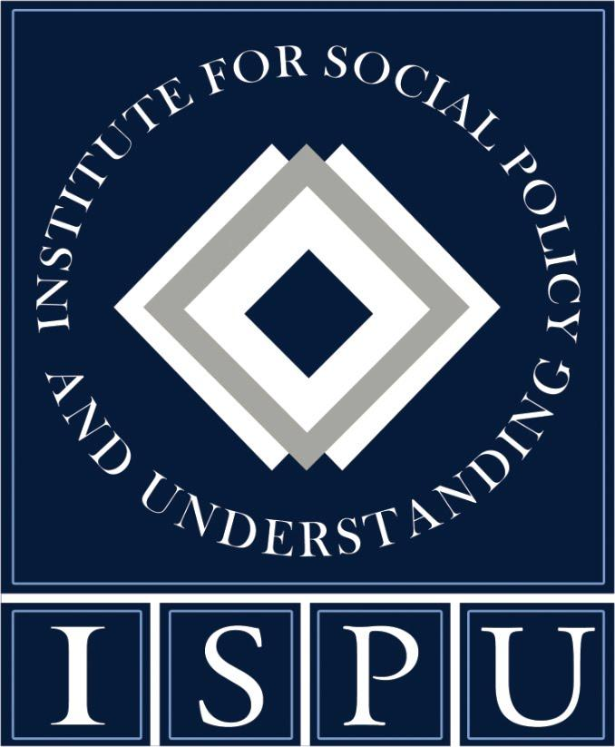

**A project of the Institute for Social Policy and Understanding (ISPU)**

***What you need to know about hosting***

Thank you for your interest in hosting the Institute for Social Policy and Understanding’s (ISPU) Native American and Indigenous Muslim Stories: Visions and Voices portrait exhibit. This document contains details about the exhibit and any requirements for hosting. Of course, we are always just a phone call or email away, so if you need anything at all, please reach out.

***Exhibit Title***

**Native American and Indigenous Muslim Stories: Reclaiming the Narrative**

*Visions and Voices Portrait Exhibit*

***Exhibit Description***

Native Americans are often invisible in our public discussion of America, and even more so in any discussion of Muslims in the United States. As a group, Native Americans broadly make up 1.8% of the US general population. As such, they are often overlooked, invisible and underrepresented in public conversations and decision-making. And Muslims broadly make up an estimated 1.1% of the US general population. Among Muslims in the United States, Native Americans make up just 1-2%. There is an absence of awareness and lack of representation of Native American and Indigenous Muslims both in the broader US public and within the US Muslim community.

**Native American and Indigenous Muslim Stories: Reclaiming the Narrative project (NAIMS)**, the first comprehensive study of its kind, is centered around spreading awareness of the lived experiences of Native American and Indigenous Muslims in the United States.

***Visions and Voices***, the first publication from ISPU's Native American and Indigenous Muslim Stories (NAIMS): Reclaiming the Narrative project, is the first-ever photo narrative project to center the lived experiences of Native American and Indigenous Muslims in the United States. This research amplifies Indigenous Muslim voices to highlight the challenges, strengths, and needs of this small but incredibly diverse community. ISPU researchers conducted 17 in-depth, semi-structured interviews with Native American Muslims over a period of six months. Interviews explored identity, ways to navigate multiple marginalized communities, and insights into participants' struggles, hopes, and dreams. From these interviews, professional storytellers developed and summarized participant stories. Photographers met each of these participants in their communities all across the United States to capture portraits. By centering their voices and images, this form of storytelling opens up the possibilities of new ways of understanding, disrupts dominant narratives about Native American and Indigenous Muslims and helps audiences contemplate broader themes of identity and what it means to be an American today.

You can explore full report materials online: <https://www.ispu.org/naims-report/>

***Exhibit Components***

The specifications of the exhibit are as follows:

1. We offer hosts access to 17 portrait downloads, which should be printed on high quality light foam board, highlighting featured individuals from across the country. Each portrait should be measured 24 X 36 inches and is designed to be displayed on an easel or hung on a wall.
2. The exhibit includes an additional board that has contextual information, including an introduction to the research project and to ISPU, as well as a one page print out, both of which must accompany the exhibit and be accessible to audiences.
3. The portraits can be shipped to your requested location by one of our suggested printing partners.

*Easel Display printing options:*

* 24" x 36" foam board; color printed vertically
* [Vistaprint](https://www.vistaprint.com/signs-posters/foam-board-signs) $37/per foam board + shipping
* [Uprinting](https://www.uprinting.com/foam-boards.html?aind=prod_up_products&aqid=c3cbf4f0524b56ed9d5e32b91206fee0&aoid=fd4b8898ffba63e2c4d974c30fff2cb41a49196bea1e2d0272c8e3f8165a9911&apos=1&aut=03ec8fde-83ce-11ee-8726-0242ac110003-1700063134&asrc=lookahead&akywd=foam&stype=algolia&mdl=products) $40/per foam board + shipping
* [Gotprint](https://www.gotprint.com/products/foam-boards/order.html?mainImage=17&material=1&type=2&thickness=1&shape=15&size=10156&quantity=1) $23/per foam board + shipping
* [Amazon](https://www.amazon.com/AmazonBasics-Instant-Adjustable-Collapsible-Supports/dp/B07P8TXWYH/ref=sr_1_1_ffob_sspa?crid=3RAWAS1L47UXF&keywords=easels+for+signs&qid=1700579346&sprefix=easels%2Caps%2C113&sr=8-1-spons&sp_csd=d2lkZ2V0TmFtZT1zcF9hdGY&psc=1) Basic Easel $15/per easel

*Wall Display printing options:*

* 24" x 36" poster; color printed vertically
* [Vistaprint](https://www.vistaprint.com/signs-posters/posters) $21/per poster + shipping
* [Uprinting](https://www.uprinting.com/large-format-posters-printing.html) $30/per poster + shipping
* [Gotprint](https://www.gotprint.com/products/large-format-posters/order.html?size=313&paper=16&quantity=1) $22/per poster + shipping
* [Velcro Command Strips](https://www.amazon.com/Command-Picture-Hanging-16-Pairs-PH204-16ES/dp/B073XS3CHV/ref=sr_1_3?crid=13SXS9SAG3HHS&keywords=velcro%2Bmedium%2Bcommand%2Bstrips&qid=1700579560&sprefix=velcro%2Bmedium%2Bcommand%2Bstrips%2Caps%2C100&sr=8-3&th=1) picture hanging strips (need 8/per poster) $10-$12 for 32 strips

1. Hosts should submit materials requests at least 6 weeks in advance of their exhibit date to give themselves enough time to print and ship the exhibit boards. The host/exhibitor keeps all materials after the event(s).
2. At an additional cost, ISPU staff may be available to give a presentation on our research on Native American and Indigenous Muslims. ISPU requests that such requests be made at least 8 weeks in advance to ensure the availability of the ISPU staff.
3. ISPU takes its tagline “research making an impact” very seriously. We would love to hear how the exhibit goes, how it is helpful, and any feedback or audience reactions you are willing to share! We may reach out to you, or feel free to email any feedback to info@ispu.org.

***Costs***

We ask hosts to incur the costs of printing and shipping the portraits and an informational one-pager about the research via our suggested options found above, as well as any associated installation costs, such as purchasing easels and/or command strips. We are not able to ship easels for borrowing. Hosts are responsible for installing and dismantling the exhibit.

If you are interested in having an ISPU staff member present on Native American and Indigenous Muslim Stories, we ask hosts to cover travel expenses for that individual, in addition to a $1000 stipend per person.

***Intellectual Property and Right to Use***

ISPU is, and will remain, the sole and exclusive owner of all rights, title, and interest to all digital images for the portraits. Portraits may not be used in any other means outside of the Native American and Indigenous Muslim Stories: Visions and Voices portrait exhibit.

***Next Steps***

If you are interested in hosting a Visions and Voices exhibit, [please fill out this form](https://share.hsforms.com/1N1-qWEyvSY6hQen7hEueTAcx5do?__hstc=13299560.3a69171cd798aabc1437f30aac3e9165.1681827453549.1701271658869.1701287598619.311&__hssc=13299560.1.1701287598619&__hsfp=3755259113). We will reach out after receiving your request. For additional information please contact us at [info@ispu.org](mailto:info@ispu.org)

***About ISPU***

The Institute for Social Policy and Understanding [(ISPU) provides objective research and education about American Muslims to support well-informed dialogue and decision-making. Since 2002, ISPU has been at the forefront of discovering trends and opportunities that impact American Muslim communities. Our research aims to educate the general public and enable community change agents, the media, and policymakers to make evidence-based decisions. In addition to building in- house capacity, ISPU has assembled leading experts across multiple disciplines, building a solid reputation as a trusted source for information for and about American Muslims.

For more information, visit us at [www.ispu.org](http://www.ispu.org). Or, ask us any questions you might have about our work and impact at info@ispu.org!